Design and Prototyping

**COURSE REGISTRATION SYSTEM**

**IST 659 – Data Administration Concepts & Database Management System**

**Submitted to:**

Hernando Hoyos

**Team Members:**

Madhavi Kadam

Nidhi Shivakumar

**Contents**

PROJECT SUMMARY .............................................................................................................................3

ENTITY AND ATTRIBUTE TABLE

.............................................................................................................................4

ENTITY-RELATIONSHIP DIAGRAM

.............................................................................................................................7

CREATION OF TABLES .............................................................................................................................8

MAJOR DATA QUESTIONS

...........................................................................................................................13 FORMS

...........................................................................................................................15

REPORT

...........................................................................................................................18

TRIGGER

...........................................................................................................................20

**PROJECT SUMMARY**

Course registration system is an integrated system that allows the institution which maybe a school, college or University to post courses for the students to register. The same course may be taught by more than one instructor and the same instructor may have more than one batch for the same course as well. Each batch of the course will have a unique identification number so as to prevent any confusion. Students can register for the courses based on their preferred instructor, suitable day or time, course availability and other criteria like prerequisites. Once a student registers for a course it will automatically be added to their schedule thereby enabling the system to guide the student so as to prevent clashes in their schedule.

Since the present course registration system does not have an efficient way of assigning classes to the students and it’s based on luck and the fact that whoever gets through the system quickly and first is given the course irrespective of any other criteria. Since a particular course can be in more demand and may be helpful for the students to get an internship or full time opportunity there needs to be a fair and logical way of assigning the courses to students based on the previous grades or performance as well as courses taken up by the student.

Also since students are often confused and without proper research and guidance may end up taking a course which will not really help in the track they are targeting and will lead to the students spending their value time and money on something which they didn’t want to do and they realize it only later. Since there is no such automated  provision which can help the students decide which course may be more helpful for them to target the track they want to complete and hence be more able to get the opportunities they are interested in

There can be a more efficient way of assigning classes based on waiting lists by just creating a completely separate cart where the student can add all the classes they want to waitlist if it is already full. And based on the time of submission of the cart the student will be added to the waitlist for all the classes that the student has in their cart which can be later updated be the student.

**ENTITY AND ATTRIBUTE TABLE**

1. **Student**

This entity captures information about the student who signed up for the services and accommodation requested.

|  |  |  |  |  |
| --- | --- | --- | --- | --- |
| Entity Name:  Student | Attribute Name | Field Type | NULL/NOT NULL | Explanation |
| PRIMARY KEY | net_id | int | NOT NULL | Unique Identifier for Student Entity |
| OTHER ATTRIBUTES | password | int | NOT NULL | Password to Login to the System |
|  | fname | VARCHAR | NOT NULL | First Name of the student |
|  | lname | VARCHAR | NOT NULL | Last Name of the student |
|  | GPA | int | NULL | Grade Points of the Student |

1. **Course**

This entity capture the information of the courses in which the students are enrolled.

|  |  |  |  |  |
| --- | --- | --- | --- | --- |
| Entity Name: Course | Attribute Name | Field Type | NULL/NOT NULL | Explanation |
| PRIMARY KEY | course_id | int | NOT NULL | Unique Identifier for Course Entity |
| FOREIGN KEY | dep_id | int | NOT NULL | Primary key associated with Department Entity |
| FOREIGN KEY | emp_id | int | NOT NULL | Primary key associated with Professor Entity |
| OTHER ATTRIBUTES | course_name | VARCHAR | NOT NULL | Name of the Course |
|  | course_prereq | VARCHAR | NOT NULL | Prerequisite of the Course |
|  | course_description | VARCHAR | NOT NULL | Description of the Course |
|  | course_professor | VARCHAR | NOT NULL | Professor Teaching the Course |
|  | course_technologies | VARCHAR | NOT NULL | Technologies used in the Course |
|  | course_min_gpa | int | NOT NULL | Minimum GPA Required for the Course |

1. **Waitlist**

This Entity captures the information of the students and courses wait listing the courses.

|  |  |  |  |  |
| --- | --- | --- | --- | --- |
| Entity Name: Waitlist | Attribute Name | Field Type | NULL/NOT NULL | Explanation |
| PRIMARY KEY | waitlist_id | int | NOT NULL | Unique Identifier for Waitlist Entity |
| FOREIGN KEY | net_id | int | NOT NULL | Primary key associated with Student Entity |
| FOREIGN KEY | course_id | int | NOT NULL | Primary key associated with Course Entity |

1. **Department**

This entity captures the information of the department of the school.

|  |  |  |  |  |
| --- | --- | --- | --- | --- |
| Entity Name: Department | Attribute Name | Field Type | NULL/NOT NULL | Explanation |
| PRIMARY KEY | dep_id | int | NOT NULL | Unique Identifier for Department Entity |
| FOREIGN KEY | college_id | int | NOT NULL | Primary key associated with College Entity |
| OTHER ATTRIBUTES | dep_name | VARCHAR | NOT NULL | Name of the Department |
|  | dep_advisor | VARCHAR | NOT NULL | Advisor Allotted to the Department |

1. **Professor**

This entity captures the information of the Professor teaching the courses.

|  |  |  |  |  |
| --- | --- | --- | --- | --- |
| Entity Name: Professor | Attribute Name | Field Type | NULL/NOT NULL | Explanation |
| PRIMARY KEY | emp_id | int | NOT NULL | Unique Identifier for Professor Entity |
| OTHER ATTRIBUTES | f_name | VARCHAR | NOT NULL | First Name of the Professor |
|  | l_name | VARCHAR | NOT NULL | Last Name of the Professor |
|  | address | VARCHAR | NOT NULL | Address of the Professor |
|  | salary | int | NOT NULL | Salary of the Professor |
|  | gender | VARCHAR | NOT NULL | Gender of the Professor |
|  | B_day | date | NOT NULL | Birthdate of the Professor |
|  | ph_no | int | NOT NULL | Contact Number of the Professor |

1. **College**

This entity captures the information of the College.

|  |  |  |  |  |
| --- | --- | --- | --- | --- |
| Entity Name: College | Attribute Name | Field Type | NULL/NOT NULL | Explanation |
| PRIMARY KEY | college_id | int | NOT NULL | Unique Identifier for Professor Entity |
| OTHER ATTRIBUTES | college_name | VARCHAR | NOT NULL | Name of the College |
|  | college_location | VARCHAR | NOT NULL | Location of the College |

**ENTITY-RELATIONSHIP DIAGRAM**

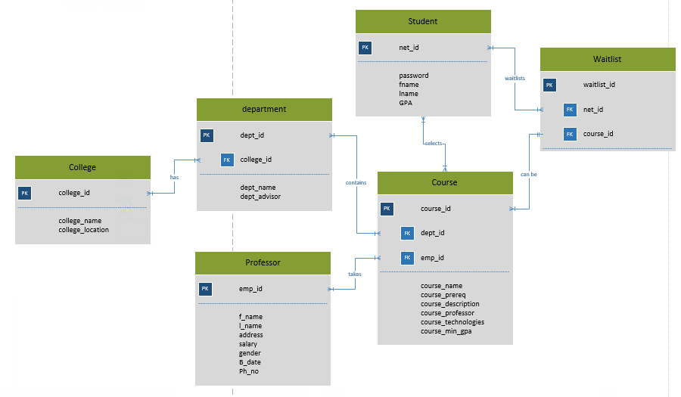

**CREATION OF TABLES**

Creating, Populating and Selecting Course Table:

create table Course(

course_id int primary key,

course_name varchar(50) not null,

course_prereq varchar(50) not null,

course_description varchar(50) not null,

course_professor varchar(50) not null,

course_technologies varchar(50) not null,

course_min_gpa int not null,

emp_id int references professor(emp_id),

dept_id int references department(dept_id));

Insert into Course values(101, 'DBMS', 100, 'Databases', 'Hernando Hoyos', 'SQL, Access, Visio',3,1,201);

Insert into Course values(110, 'Datawarehouse', 101, 'Advanced concepts', 'Taber, M.Fudge', 'SQL, Access, Visio, Data Warehouse',4,3,301)

Insert into Course values(201, 'Data Viz', 200, 'Intro to DS', 'Michael Tan', 'R',2,1,401)

Insert into Course values(301, 'Advanced Info Security', 300, 'Information Security', 'Jackson', 'Advanced concepts of info sec',2,4,101)

Insert into Course values(401, 'Data Analytics', 100, 'Databases', 'Hernando Hoyos', 'R, Weka, Shiny',3,2,501)

Insert into Course values(404, 'Data Analytics', 100, 'Databases', 'Yang Wang', 'R, Weka, Shiny',3,2,501)

Insert into Course values(304, 'DBMS', 100, 'Databases', 'Yang Wang', 'R, Weka, Shiny',3,2,501)

Insert into Course values(305, 'DBMS', 100, 'Databases', 'Yang Ling', 'R, Weka, Shiny',3,2,501)

Select * from course;

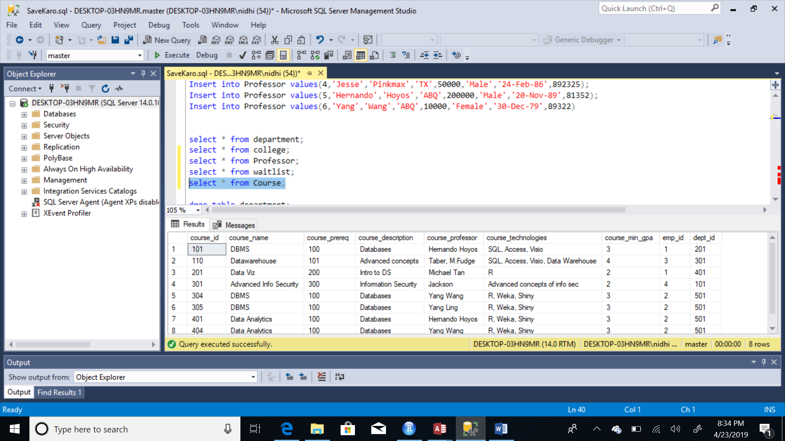

Creating, Populating and Selecting Student Table:

create table Student(

net_id int primary key,

password varchar(10) not null,

fname varchar(10) not null,

lname varchar(10) not null,

GPA int

constraint chk_gpa_type CHECK (GPA IN (3.0,3.1,3.2,3.3,3.4,3.5,3.6,3.7,3.8,3.9,4.0) ) not null,

course_id int references course(course_id));

insert into Student values(123, 'firebolt','Nidhi','Pathak',1.2,101);

insert into Student values(234, 'nimbus','Madhvi','Sawant',2.6,201);

insert into Student values(345, 'crucio','Devansh','Shinde',2.9,110);

insert into Student values(456, 'avada','Yash','Patel',3.0,301);

insert into Student values(567, 'kedavra','Shwet','Salvi',4.0,401);

insert into Student values(425, 'firebolt','Nidhi','Pathak',1.2,201);

insert into Student values(457, 'nimbus','Madhvi','Sawant',2.6,301);

insert into Student values(235, 'crucio','Devansh','Shinde',2.9,110);

insert into Student values(457, 'avada','Yash','Patel',4.0,101);

insert into Student values(141, 'kedavra','Shwet','Salvi',4.0,401);

insert into Student values(134, 'firebolt1','Ajaj','Pathak',1.2,101);

insert into Student values(235, 'nimbus1','Tanu','Sawant',2.6,201);

insert into Student values(467, 'crucio1','Esha','Shinde',2.9,110);

insert into Student values(583, 'avada1','tanaya','Patel',3.0,301);

insert into Student values(587, 'kedavra1','Alia','Salvi',4.0,401);

insert into Student values(124, 'firebolt2','Aliaa','Pathak',1.2,101);

insert into Student values(486, 'nimbus2','Ranbir','Sawant',2.6,201);

insert into Student values(325, 'crucio2','Deepika','Shinde',2.9,110);

insert into Student values(347, 'avada2','Arjun','Patel',3.0,301);

insert into Student values(586, 'kedavra2','Shahrukh','Salvi',4.0,401);

insert into Student values(245, 'firebolt3','Varun','Pathak',1.2,101);

insert into Student values(578, 'nimbus3','Karan','Sawant',2.6,201);

insert into Student values(235, 'crucio3','Nikhil','Shinde',2.9,110);

insert into Student values(486, 'avada3','Yash','Patel',4.0,201);

insert into Student values(579, 'kedavra3','Shwet','Salvi',4.0,401);

insert into Student values(123, 'firebolt4','Nidhi','Pathak',1.2,101);

insert into Student values(234, 'nimbus4','Madhvi','Sawant',2.6,201);

insert into Student values(345, 'crucio4','Devansh','Shinde',2.9,110);

insert into Student values(4896, 'avada4','Yash','Patel',3.7,401);

insert into Student values(567, 'kedavra4','Shwet','Salvi',4.0,401);

insert into Student values(46636, 'crucio5','Aashish','Shinde',3.9,404);

insert into Student values(4846, 'avada5','Jay','Patel',3.7,404);

insert into Student values(23525, 'kedavra6','Nakul','Salvi',4.0,404);

select * from student;

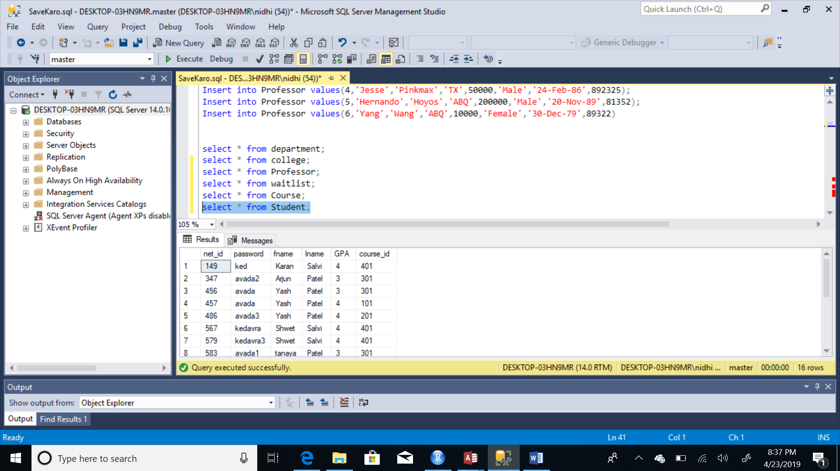

Creating, Populating and Selecting Professor Table:

Create table Professor(

emp_id int PRIMARY KEY,

f_name varchar(30) not null,

l_name varchar(30) not null,

address varchar(40) not null,

salary int not null,

gender varchar(6) not null,

B_date date not null,

Ph_no int not null,

);

Insert into Professor values(1,'John','Abbot','ABQ',200000,'Male','20-Nov-89',81352);

Insert into Professor values(2,'Daisy','Hopkins','ABQ',10000,'Female','30-Dec-79',89322)

Insert into Professor values(3,'Serena','White','CBA',40000,'Female','11-June-85',894425)

Insert into Professor values(4,'Jesse','Pinkmax','TX',50000,'Male','24-Feb-86',892325);

Insert into Professor values(5,'Hernando','Hoyos','ABQ',200000,'Male','20-Nov-89',81352);

Insert into Professor values(6,'Yang','Wang','ABQ',10000,'Female','30-Dec-79',89322)

Select * from Professor;

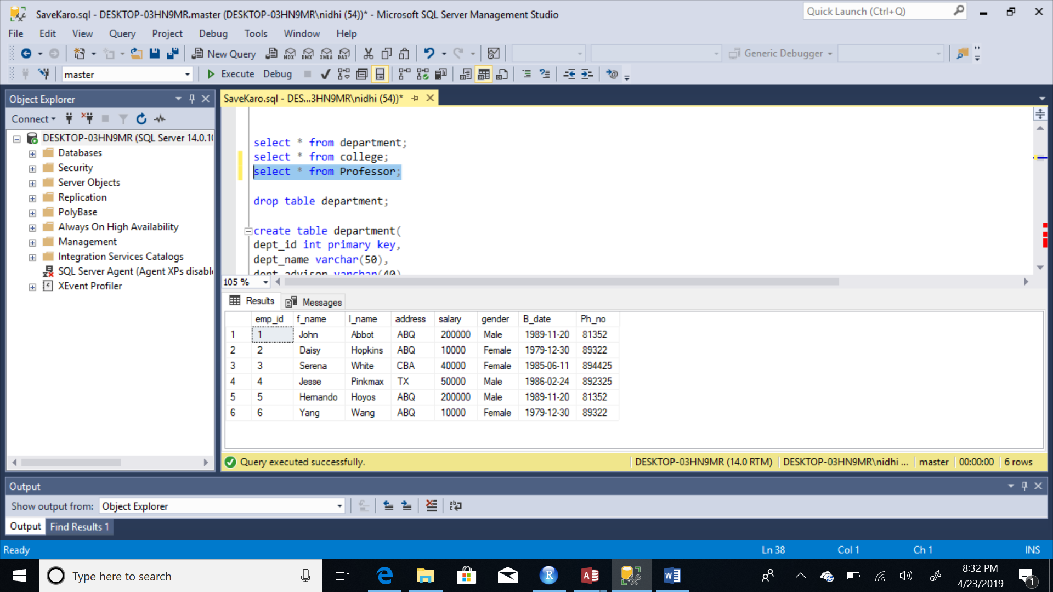

Creating, Populating and Selecting Department Table:

create table department(

dept_id int primary key,

dept_name varchar(50),

dept_advisor varchar(40),

college_id varchar(10) references college(college_id));

Insert into department values(101,'IM','Murali',3);

Insert into department values(201,'ADS','Ingrid',2)

Insert into department values(301,'CS','Hoyos',1)

Insert into department values(401,'EM','Tess',4);

Insert into department values(501,'CE','Murali',2);

Insert into department values(601,'Architecture','Yash',1);

Select * from department;

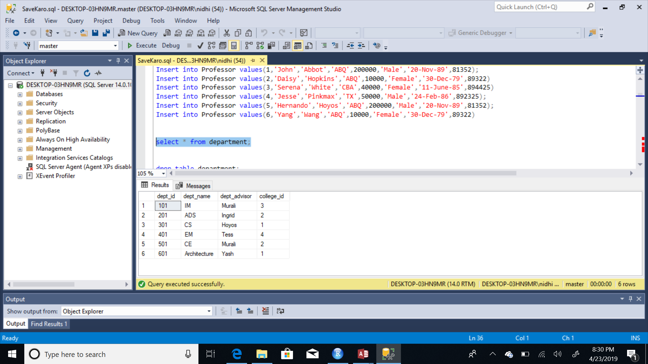

Creating, Populating and Selecting Waitlist Table:

create table waitlist(

waitlist_id int primary key,

course_id int references Course(course_id),

net_id int references Student(net_id),

GPA_1 decimal(18,10)

constraint chk_gpa CHECK (GPA_1 IN (3.5,3.6,3.7,3.8,3.9,4.0) ) not null,);

Insert into waitlist values(1,101,457,4.0)

Insert into waitlist values(2,201,457,3.8)

Insert into waitlist values(3,401,4846,3.9)

Insert into waitlist values(4,201,456,3.5)

Insert into waitlist values(5,301,567,3.6)

Select * from waitlist;

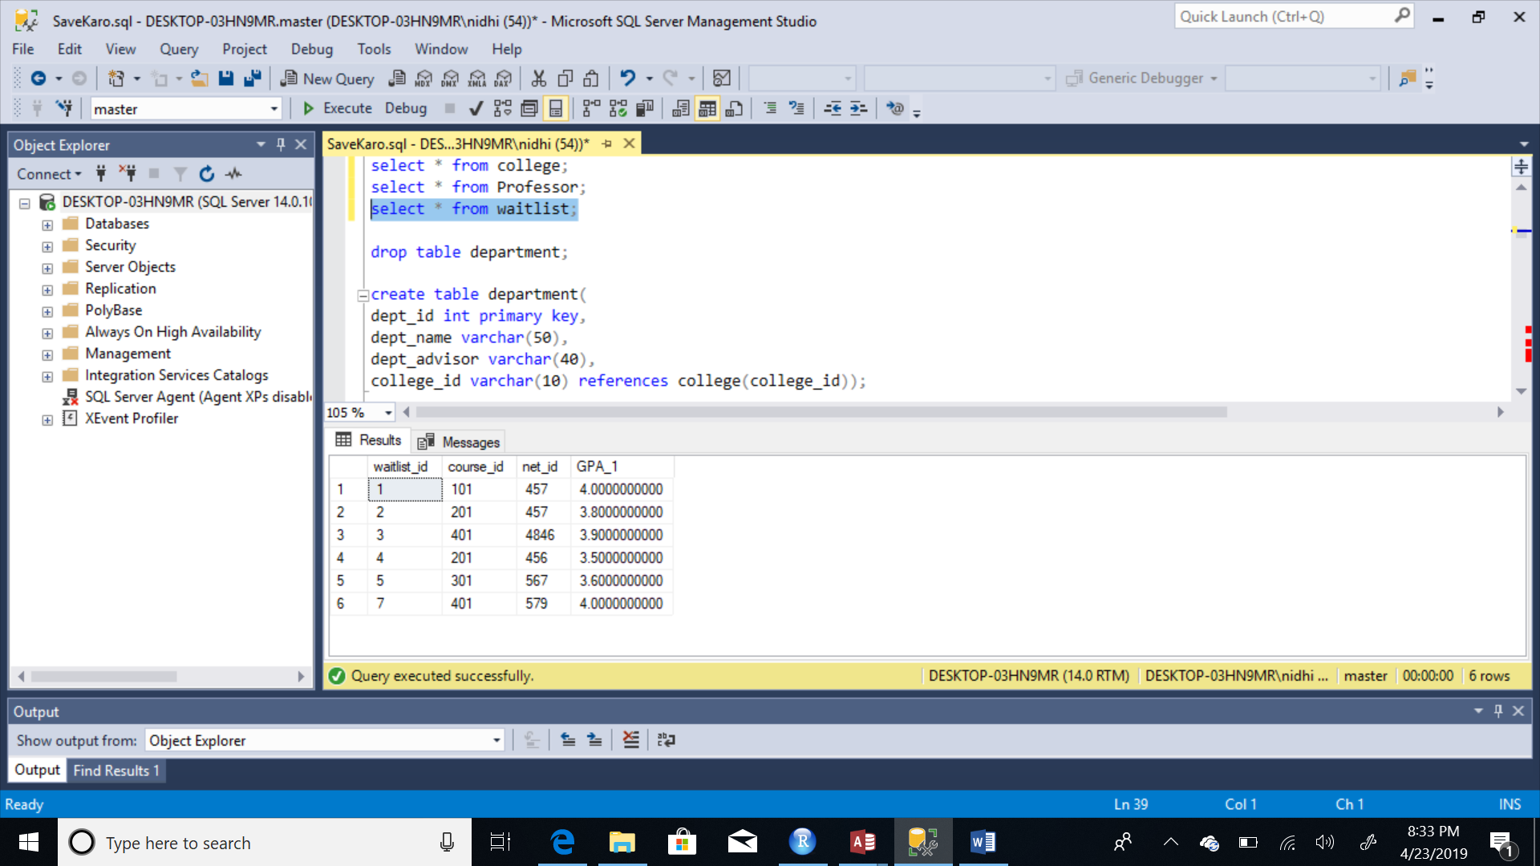

Creating, Populating and Selecting College Table:

create table College(

college_id varchar(10) primary key,

college_name varchar(10) not null,

college_location varchar(10));

insert into College values(1,'iSchool','Syracuse');

insert into College values(2,'Whitman', 'Syracuse');

insert into College values(3,'Physics', 'Syracuse');

insert into College values(4,'Geology', 'Syracuse');

select * from college;

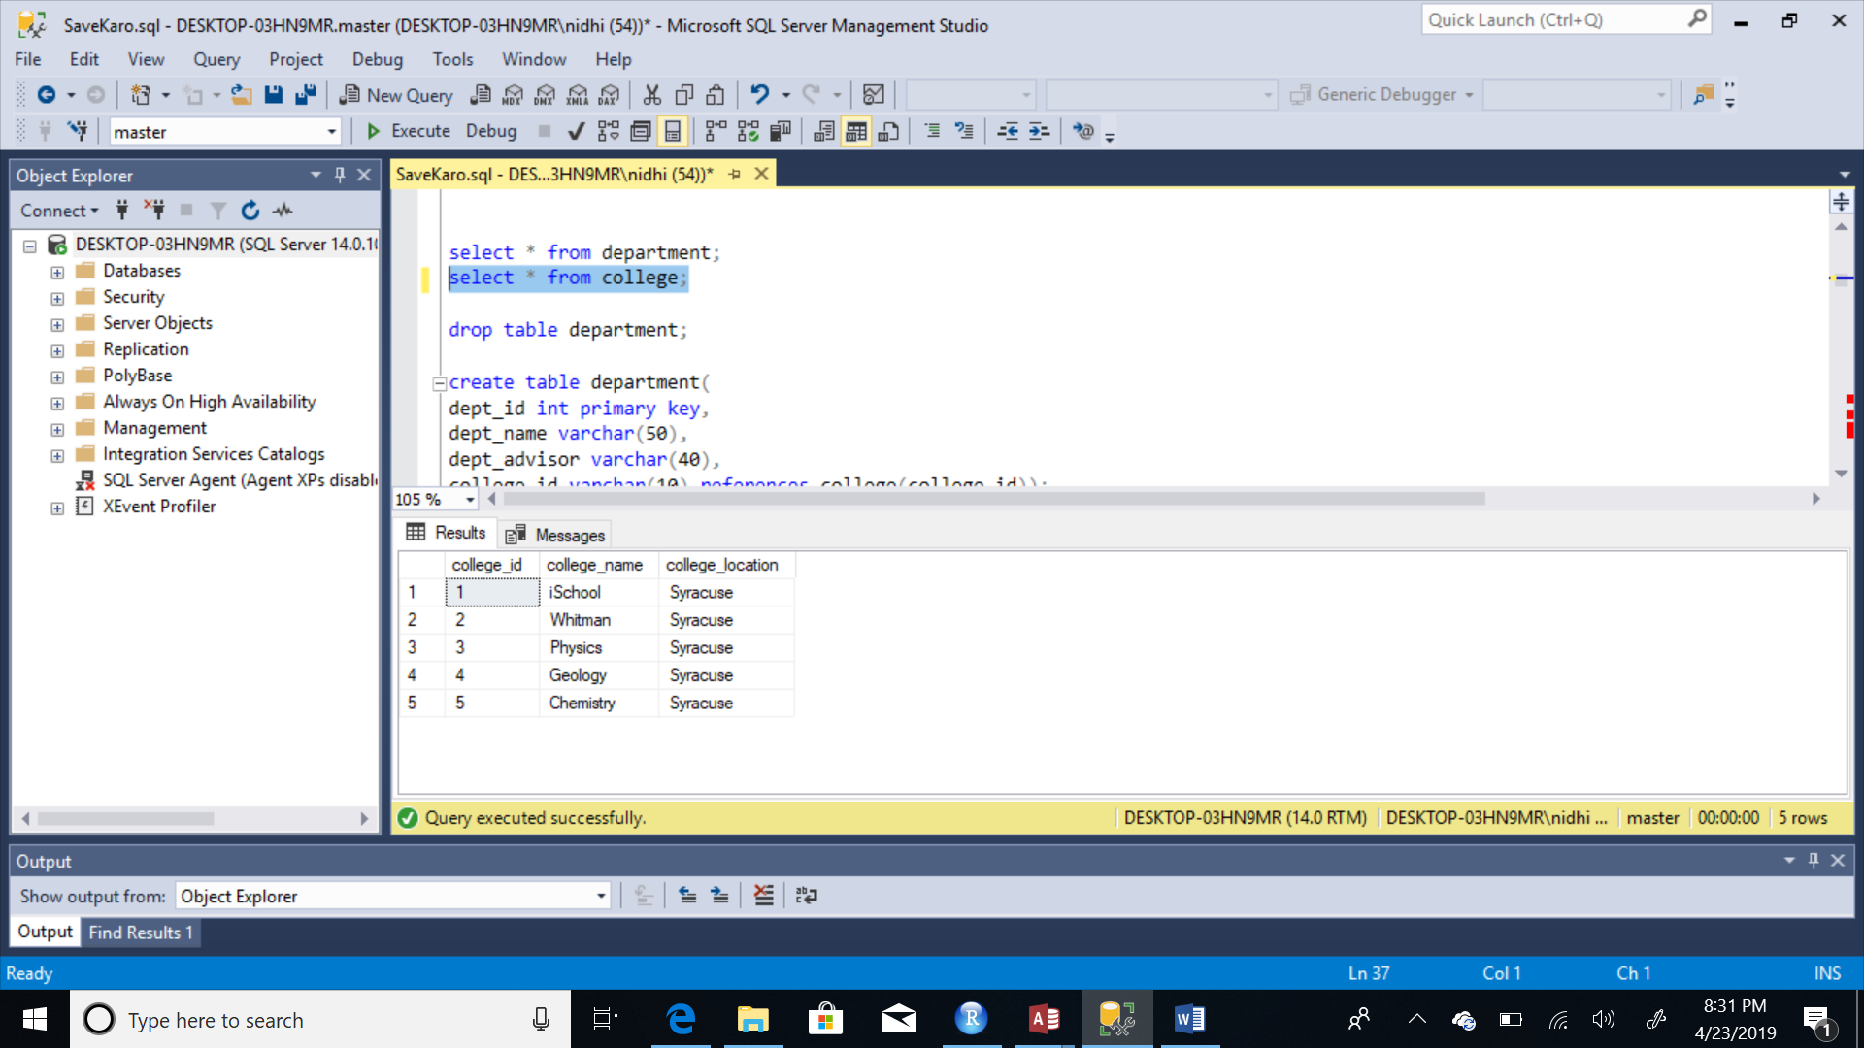

**MAJOR DATA QUESTIONS**

**Q1. What is the total count of demand for each course and their prerequisite?**

select s.course_id, count(s.course_id) as 'Total Demand', c.course_prereq

from student s

join course c

on s.course_id=c.course_id

group by s.course_id, c.course_prereq;

select w.course_id, count(w.course_id) as 'Course Demand', c.course_name

from waitlist w

join course c

on w.course_id=c.course_id

group by w.course_id, c.course_name;

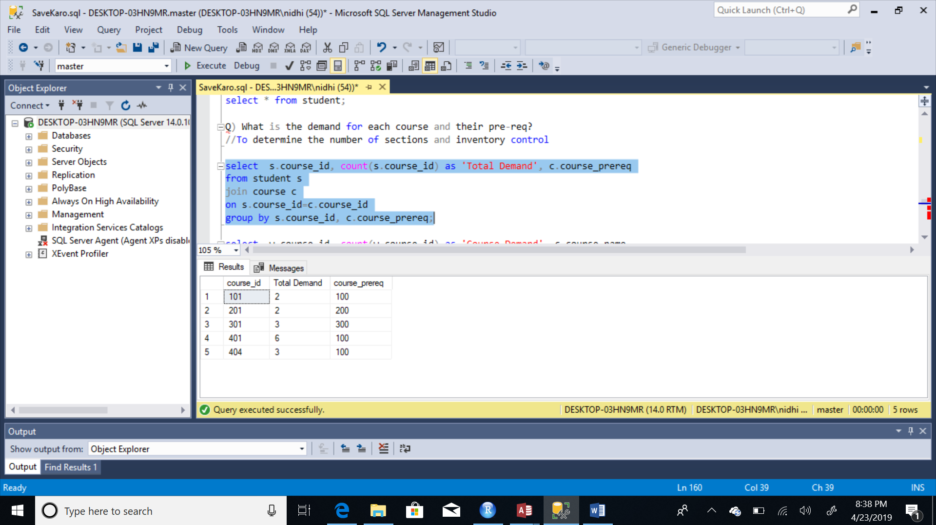

**Q2. Total number of students enrolled under a professor for the same course?**

select c.course_name, c.course_professor, count(s.course_id) AS 'Total Enrolled Students'

from student s

join course c

on s.course_id=c.course_id

join professor p

on c.emp_id=p.emp_id

where c.course_name='Data Analytics'

group by s.course_id, c.course_professor, c.course_name;

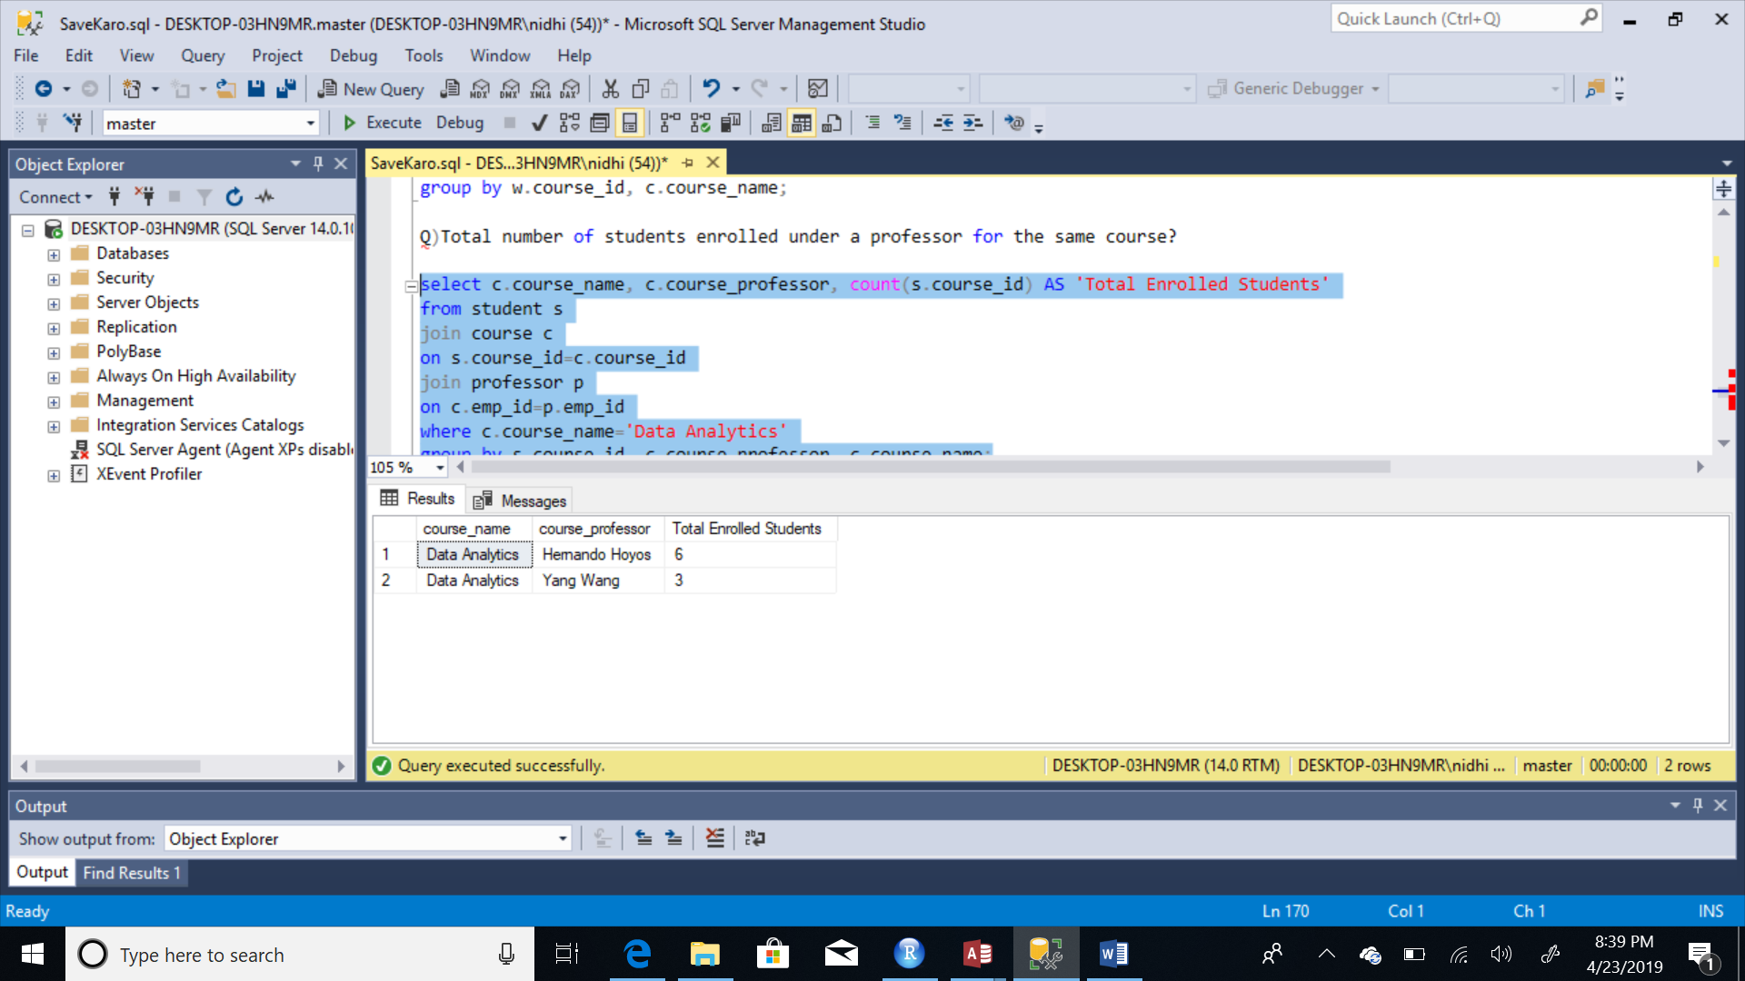

**Q3. What are the names of all the professors taking a single course?**

select course_name,course_professor

from course

where course_name='DBMS';

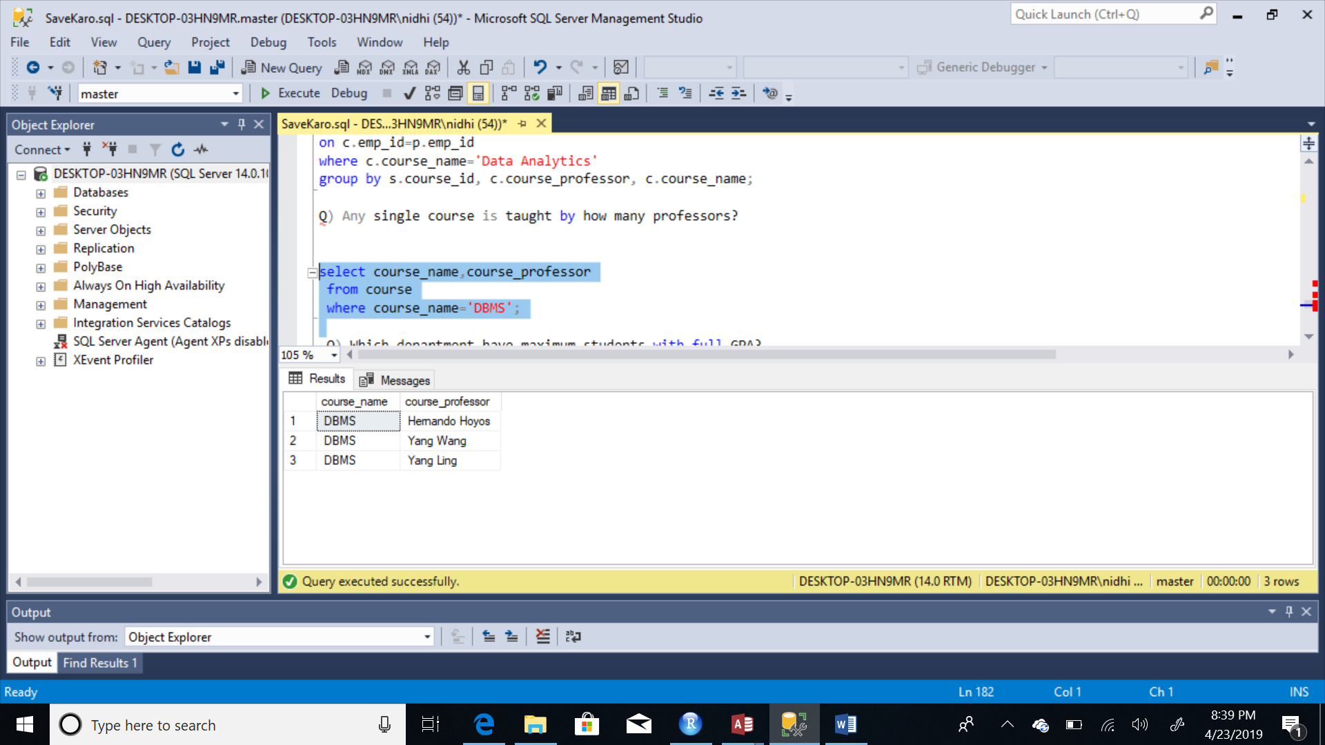

**Q4. What is the name of the department with students with full GPA?**

select s.fname, s.GPA, d.dept_name

from

student s

join course c

on s.course_id=c.course_id

join department d

on c.dept_id=d.dept_id

WHERE GPA=4;

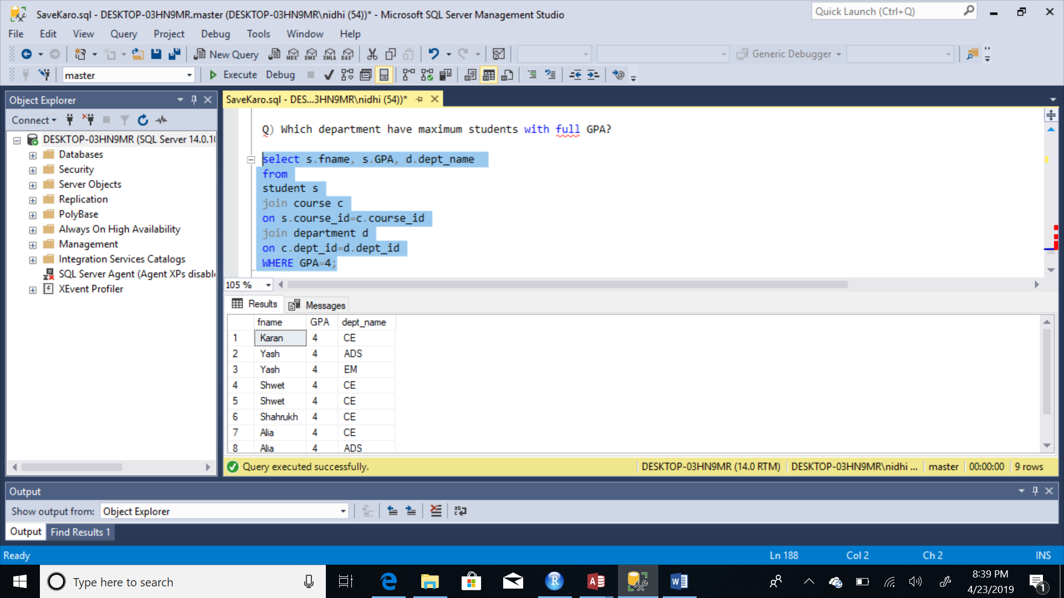

**FORMS**

**Student Sign-up Form:**

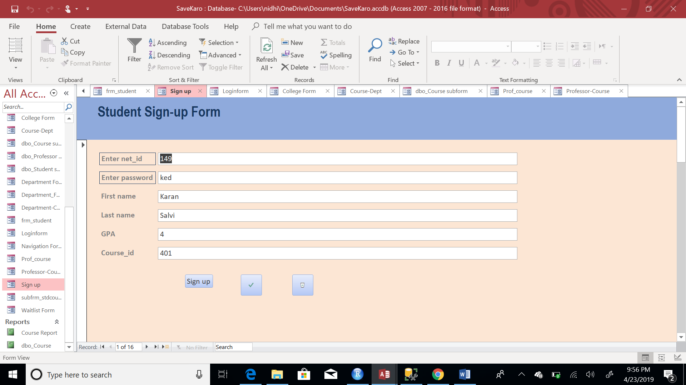

**Student Details Form:**

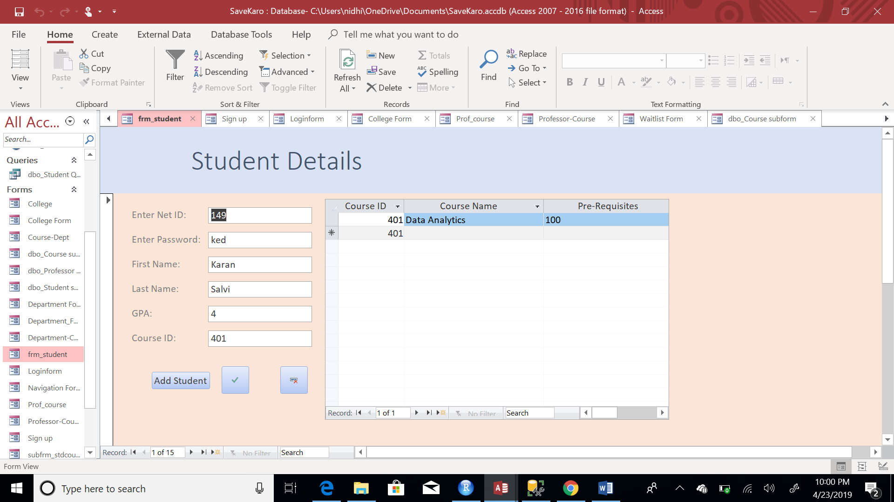

**Professor Details Form:**

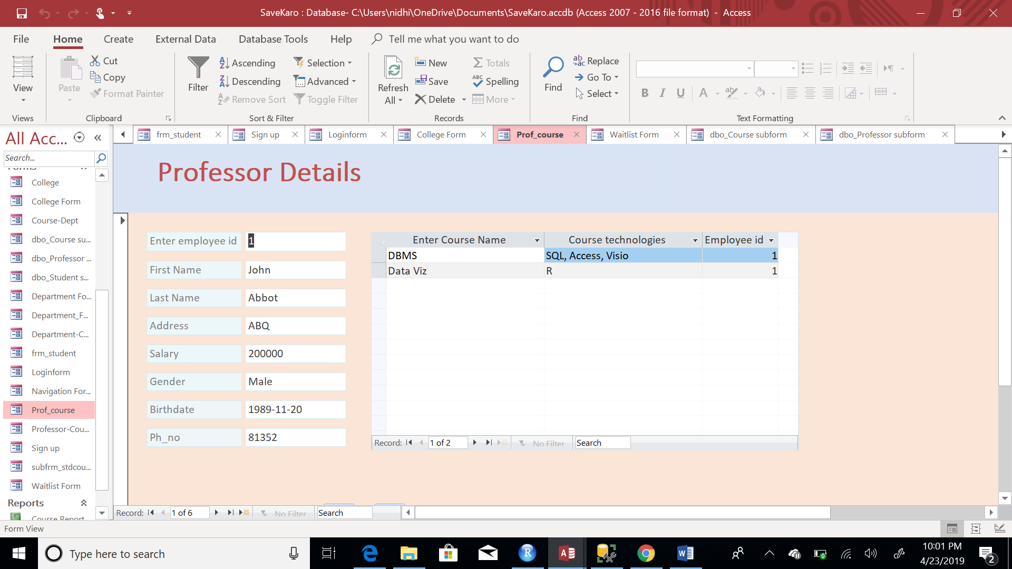

**College Details Form:**

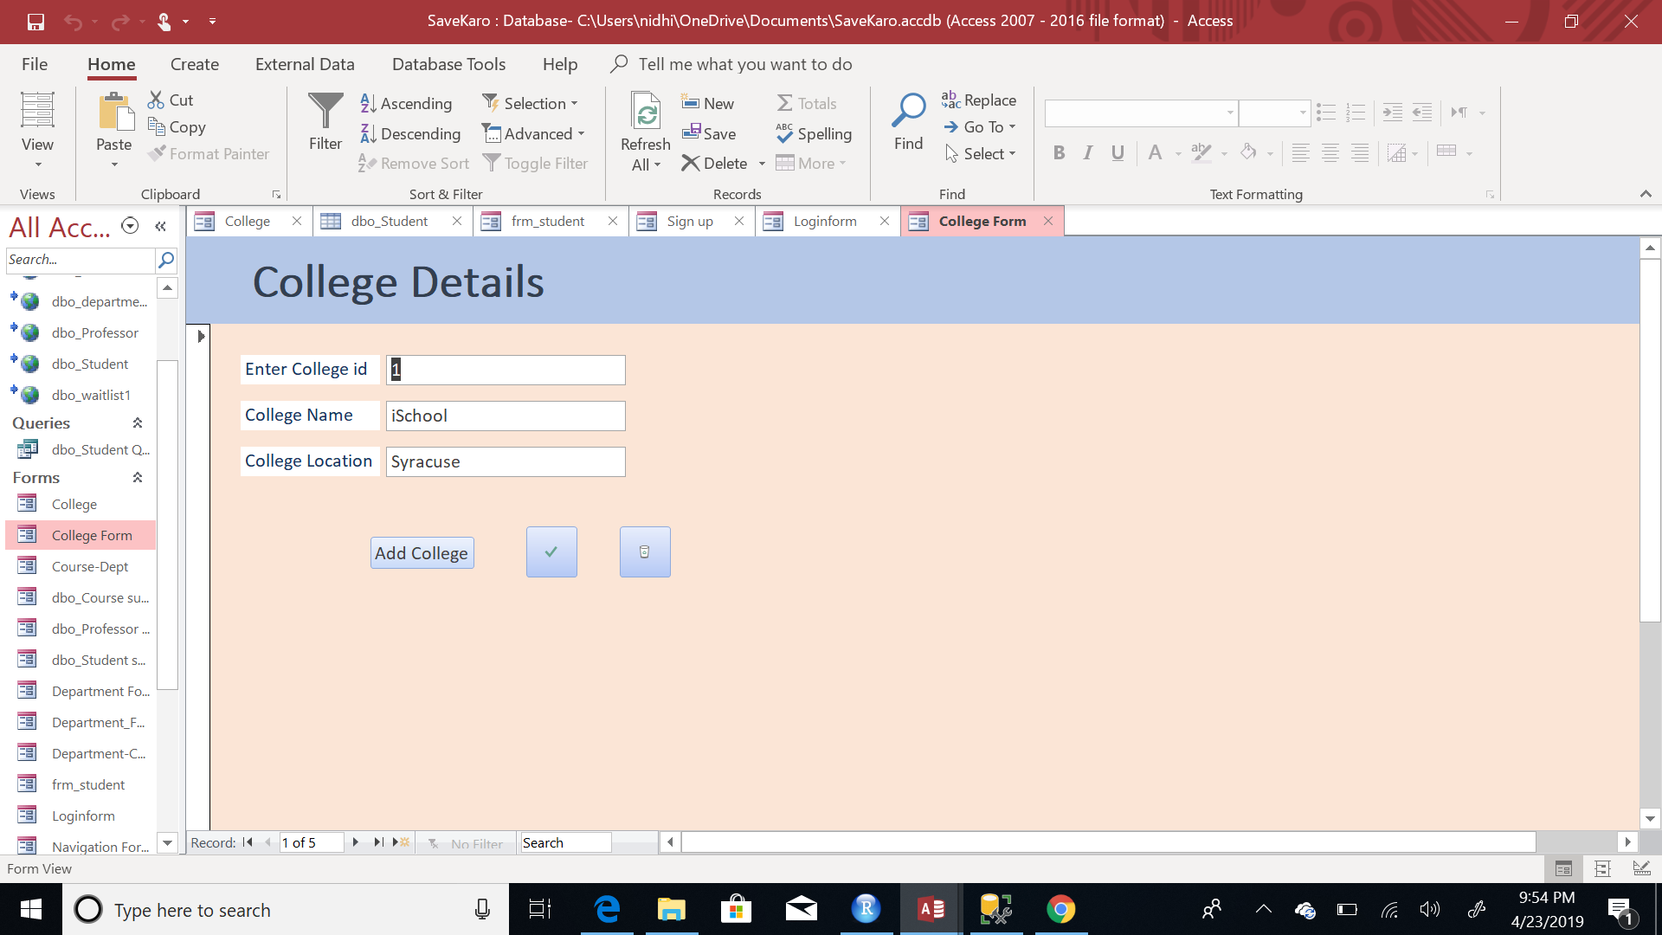

**Waitlist Details Form:**

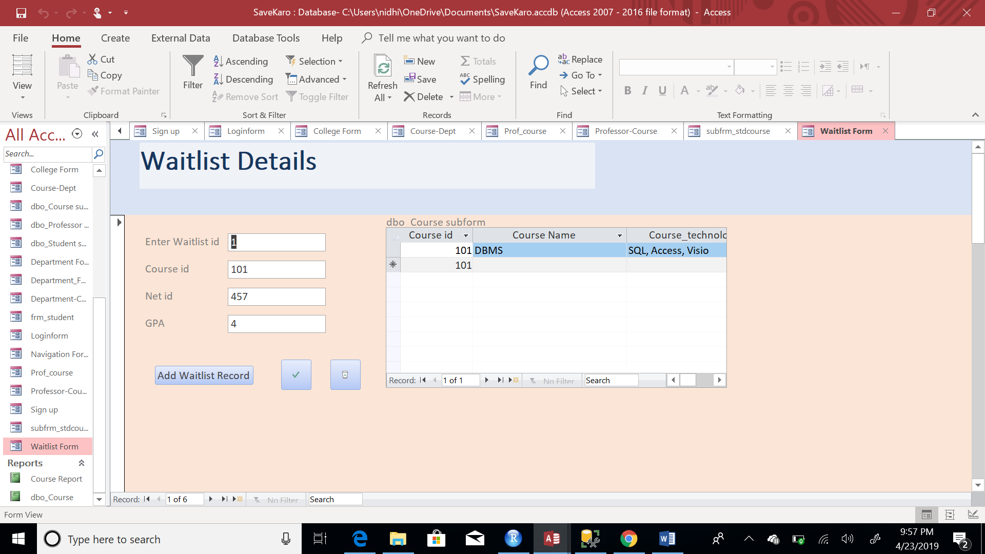

**Department Details Form:**

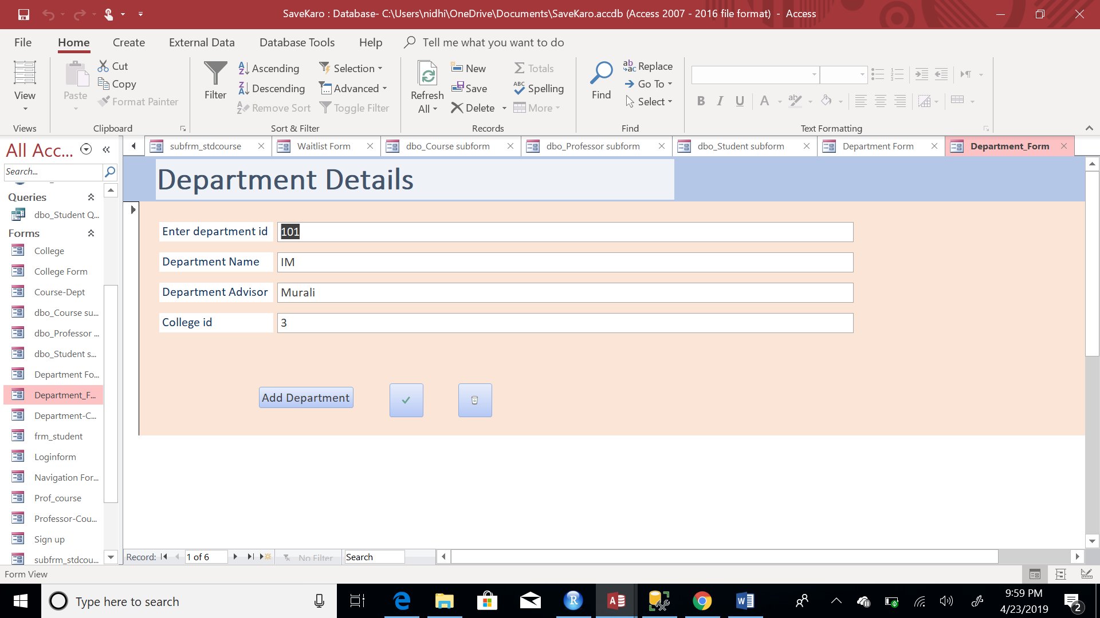

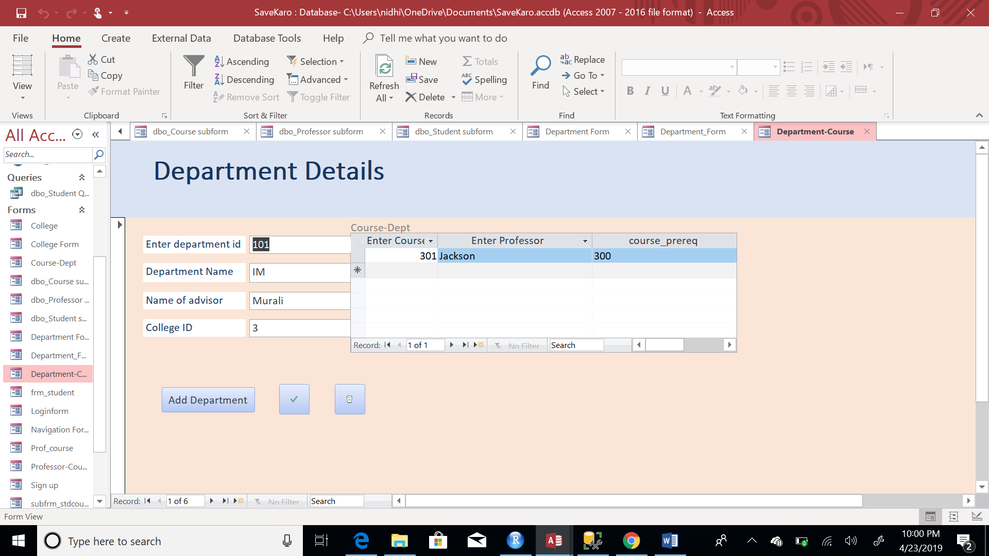

**REPORT**





**TRIGGER**

CREATE TRIGGER Stutrigger1

ON Student

AFTER INSERT, UPDATE

AS RAISERROR ('Notify Admin', 16, 10);

GO

insert into Student values(123, 'fire','NidhiSS','Kapoorrr',4,101);

SET IMPLICIT_TRANSACTIONS ON;

BEGIN TRANSACTION;

--Put multiple insert in a single transaction

insert into Student values(1563, 'pass','Pooja','Kapoor',4,101);

insert into Student values(14763, 'pass1','Ranbir','Kapoor',3.7,101);

